

**American International University- Bangladesh**

**CSC 3215: Web Technologies**

**CO1 and CO3 Evaluation**

**Project Report**

**Spring 2019-2020**

**Project Title: Private Tutor Finder**

**Section: A**

|  |  |
| --- | --- |
| Student Name | Student Id |
| Sabique Islam Khan | **18-36204-1** |
| Alvee Talukder | **16-31254-1** |

**Introduction:**

This project is all about getting a good tutor. Now a days, parents face lots of problem regarding finding a good, trustworthy and well certified tutors. Besides, the good tutors are not getting chances to serve the students as parents stop believing them. So, via this website we will be helping both sides and make sure that the parents start trusting on private tutors.

**Requirement Analysis:**

1. **User Category:**

There are 3-types of Users here. They are:

* Admin
* Parents
* Tutors

1. **Feature List:**

In this project the “Admin” has the following features:

* Can login
* Add or Remove Tutors
* Update Tutors
* Can Check registered Parents
* Edit profiles

In this project the “Parents” has the following features:

* Can login
* Can register
* Can view Tutors profile
* Can give Feedback regarding Tutors
* Edit profiles

In this project the “Parents” has the following features:

* Can register
* Can login
* Can view their ratings
* Can view their notification if any parents wants to contact with them
* Can edit profiles

**Design:**

Draw an entity relationship diagram of your project here.

**Tools Used:**

To develop this project, we have used the following:

• notepad++

**System Images against the Specification:**

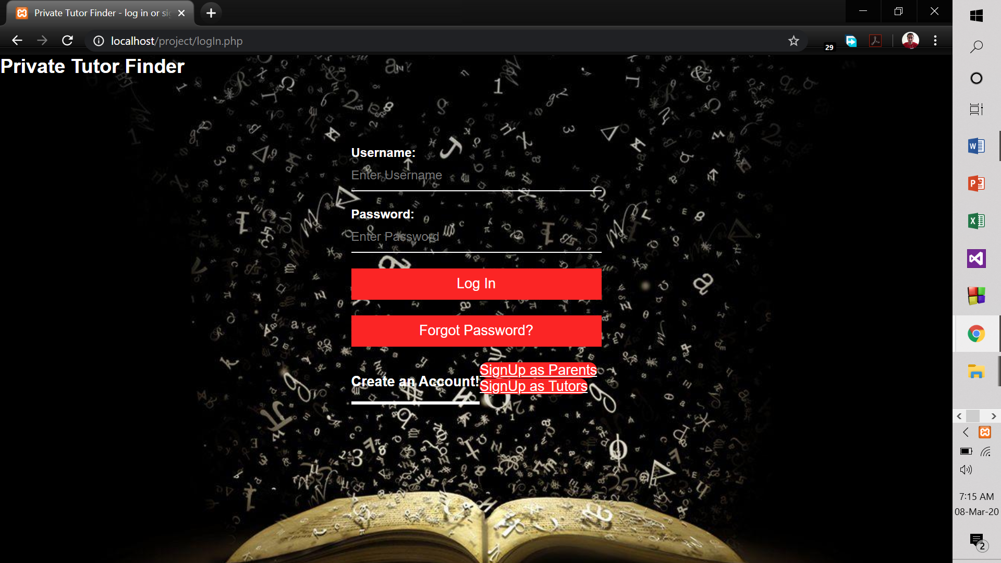

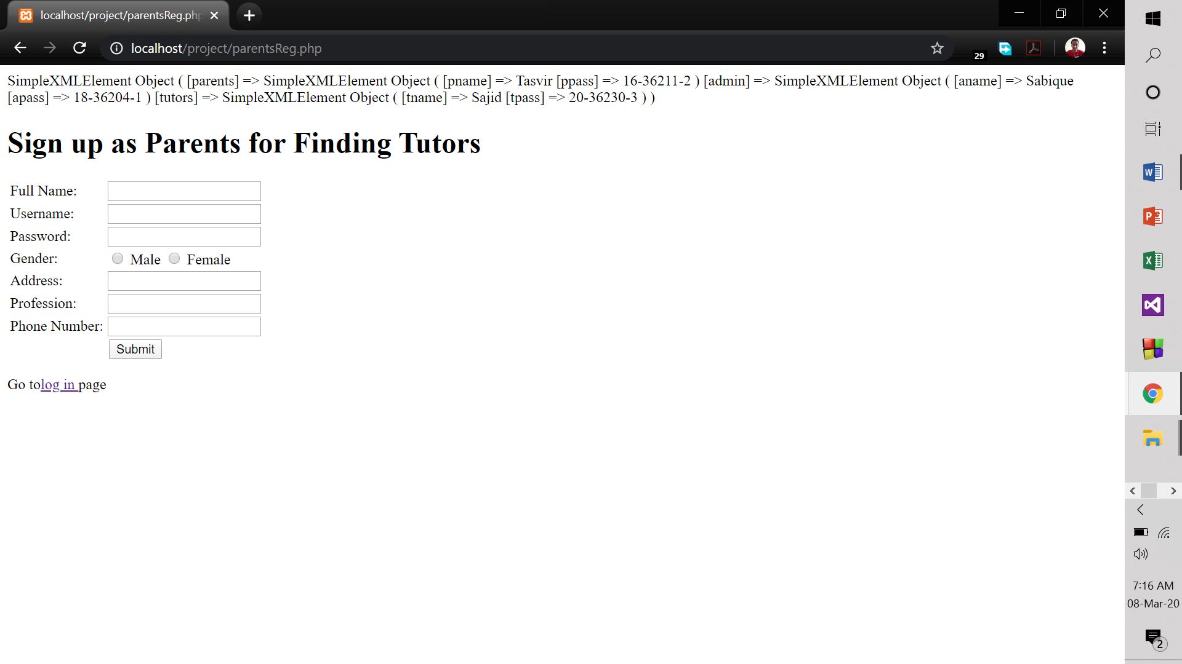

**Impact of this Project:**

Describe the increasing importance of your project on modern society and environment.

How will people be benefitted from your project?

Basically, both parents and tutors will be benefited. From recent news, we get to know that mostly primary level students are not studying and they are more into social media, thus parents are complaining about the private tutors that because of the tutors their children are learning all these instead off studying. Therefore, we came up with an idea so that the good tutors get inspired and starts serving the students. So, this is the platform where the parents will be getting tutors with authentic credentials.

**Limitations and Possible Future Improvements:**

Initially it is tough to get to the targeted audience but surely it will create an impact on the society. In the future, we will be trying to increase our database size and make it more user friendly. To make this system country wide but initially we kept it within Dhaka city only. In the form of this system, it cannot hold lots of data due to poor data storage.

***[Note: Make sure that your report is maximum 8 pages (including cover page). Print (Colored) the report and submit it with spiral bind.]***

|  |  |  |  |  |  |
| --- | --- | --- | --- | --- | --- |
| **CO1 and CO3 Evaluation: Project Report Evaluation** | | | | | |
| **Project Proposal**  **(5)** | **Background**  **Study**  **(5)** | **Requirement Analysis**  **(5)** | **Entity**  **Diagram**  **(5)** | **System Images**  **against the**  **Specification (5)** | **Total (25)** |
|  |  |  |  |  |  |
|  | | | | | |